# Assignment #5

## Task #1 – Create an Aurora DB and connect to it from EC2

1. Create Security groups for database and EC2.

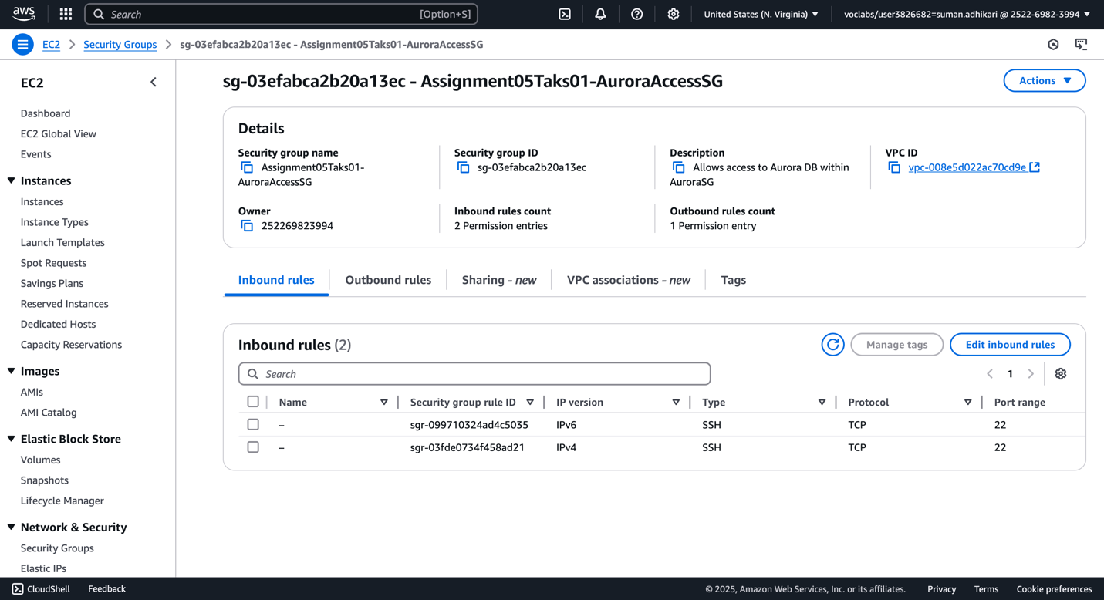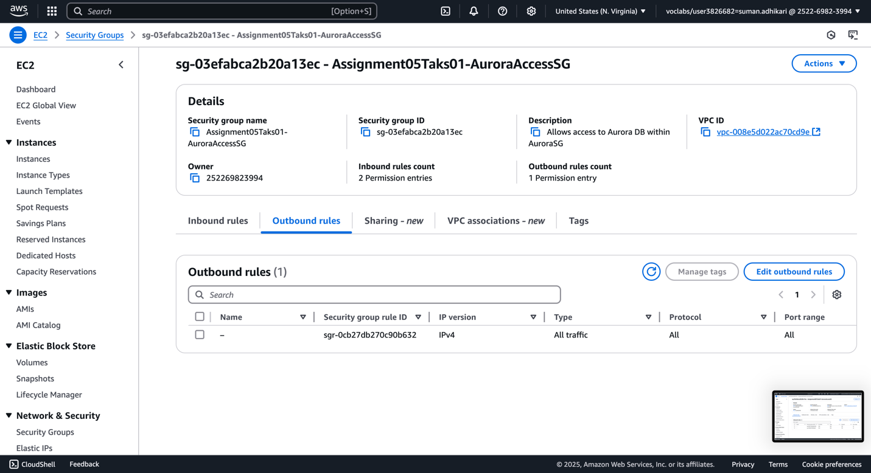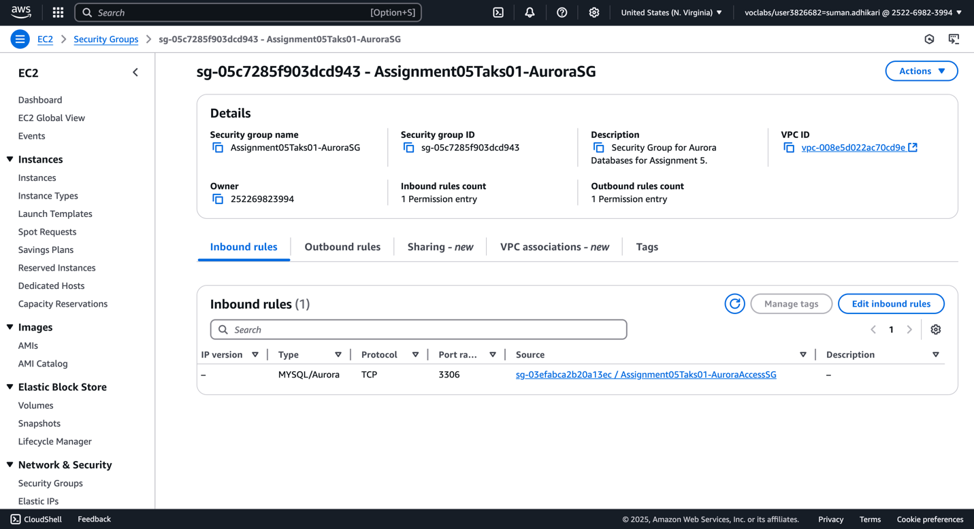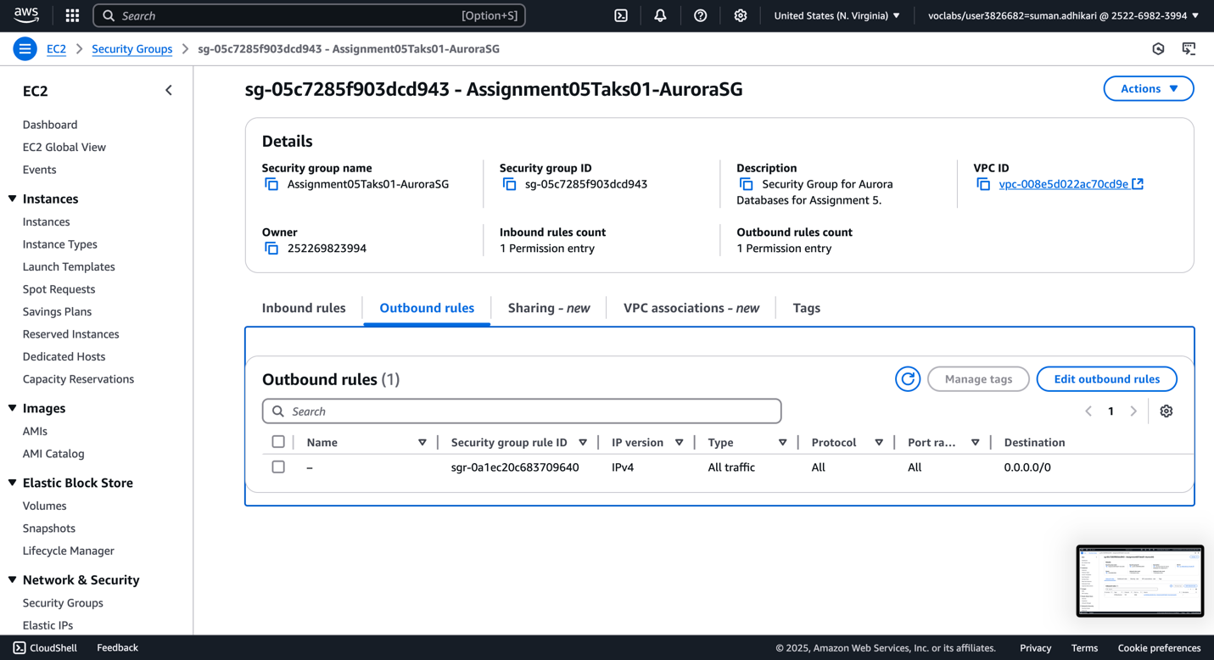

1. Create Aurora instance.

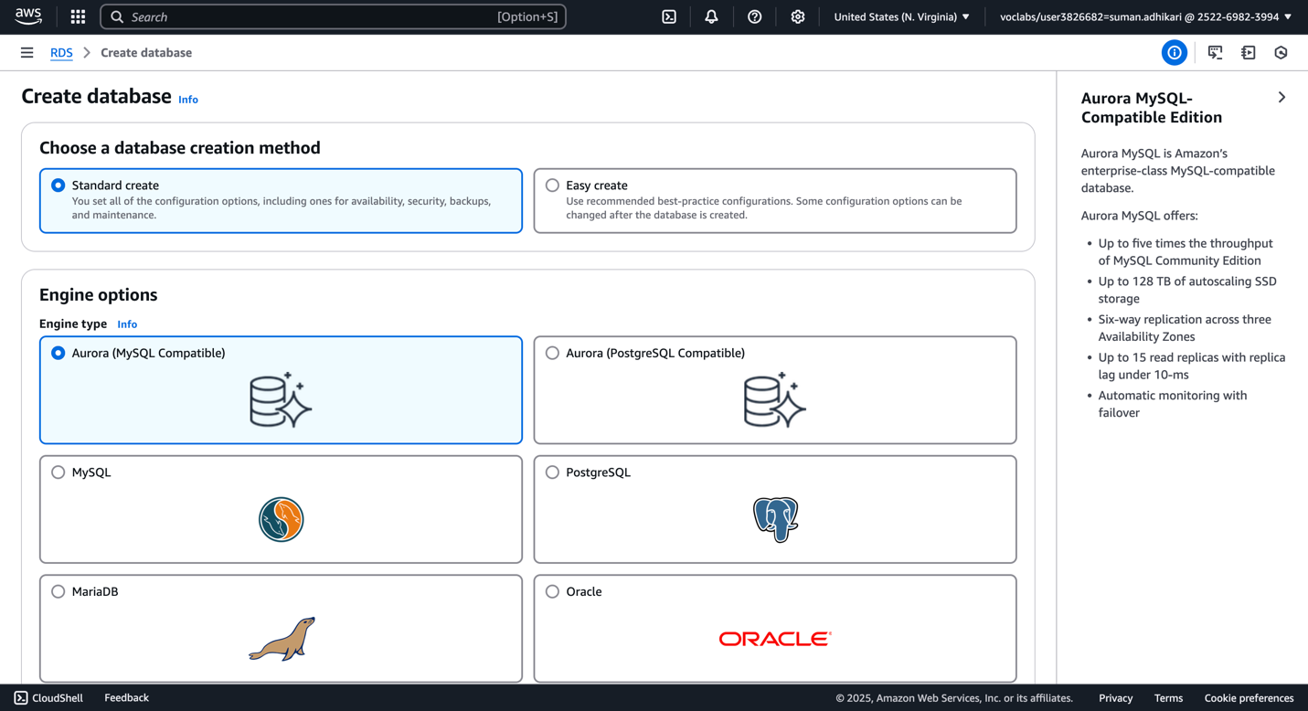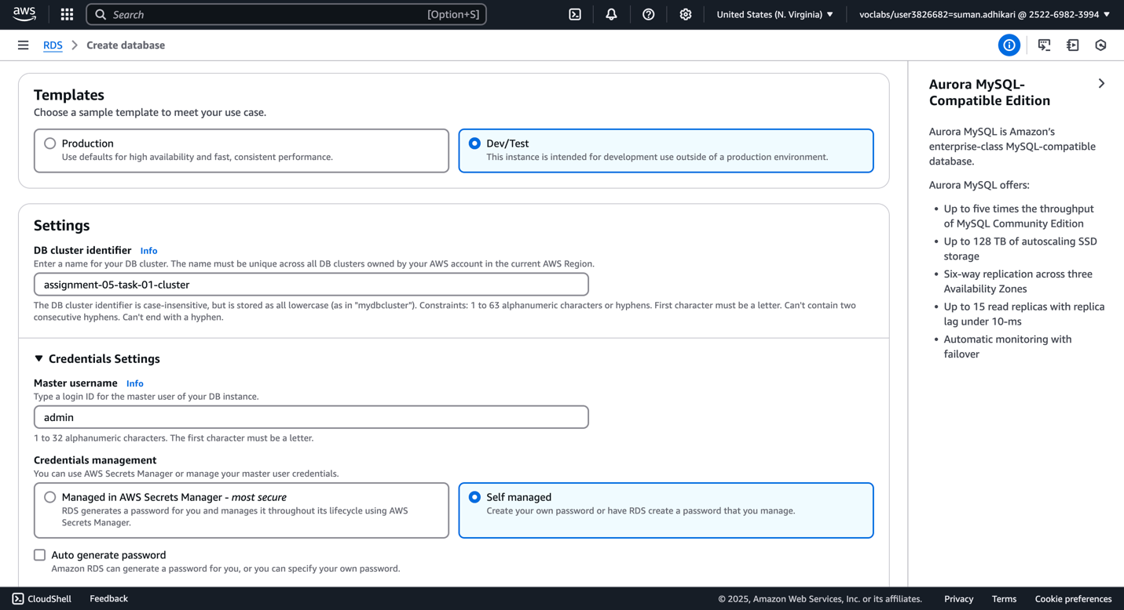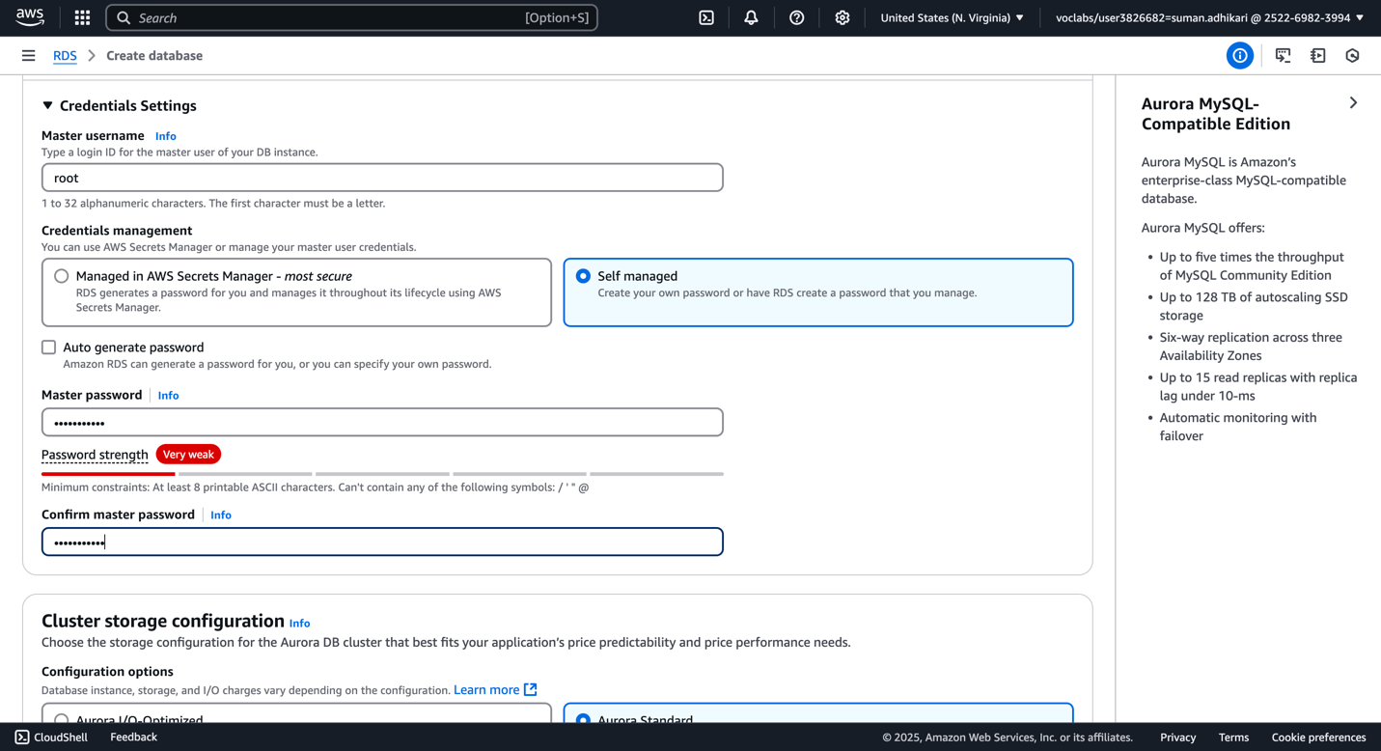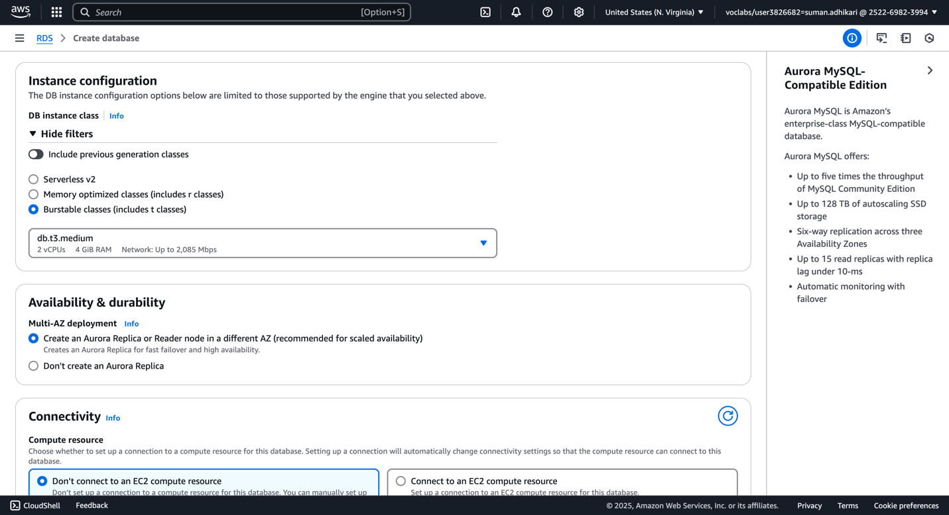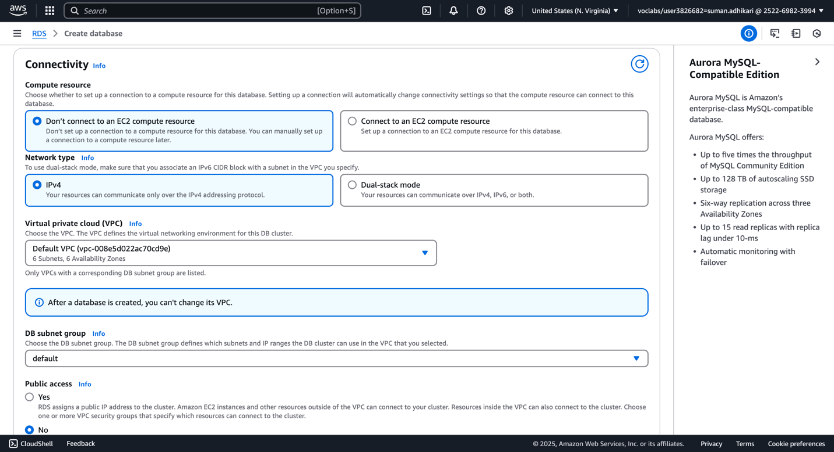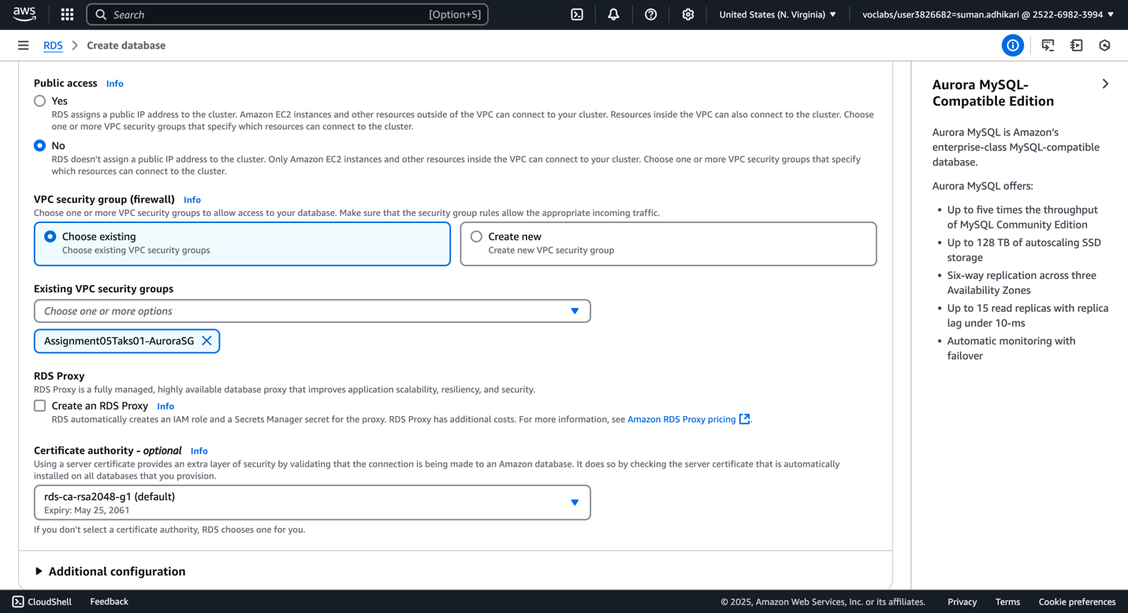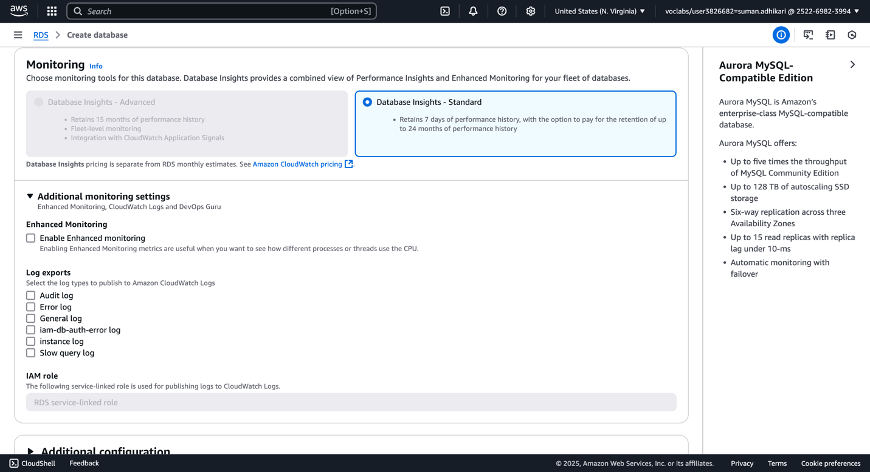

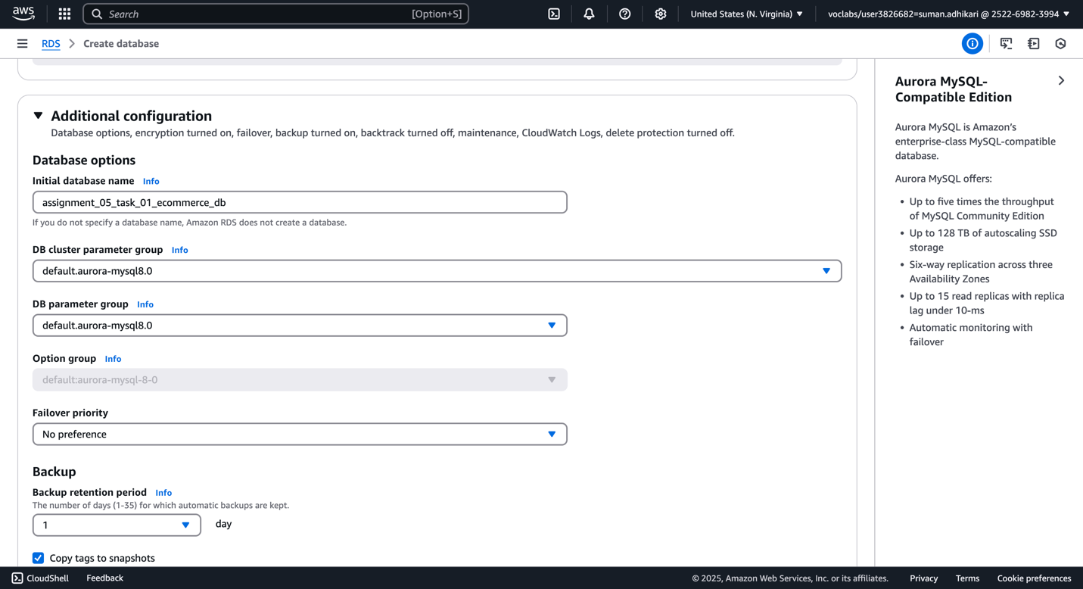

1. Aurora DB is now created with one reader and one writer instance.

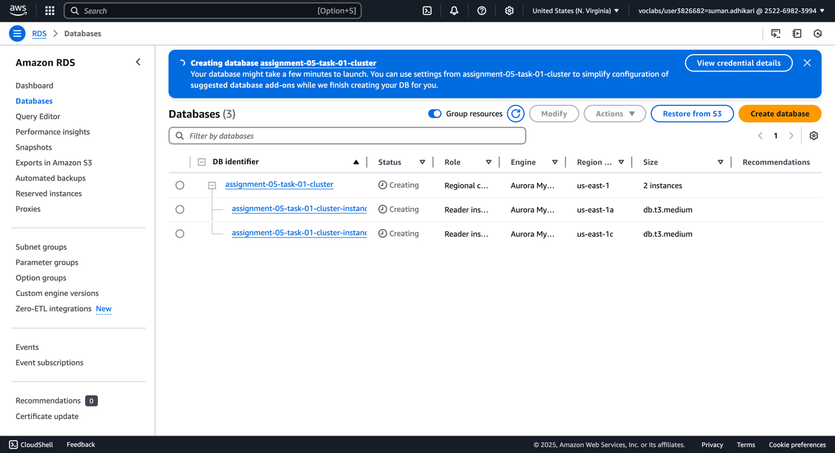

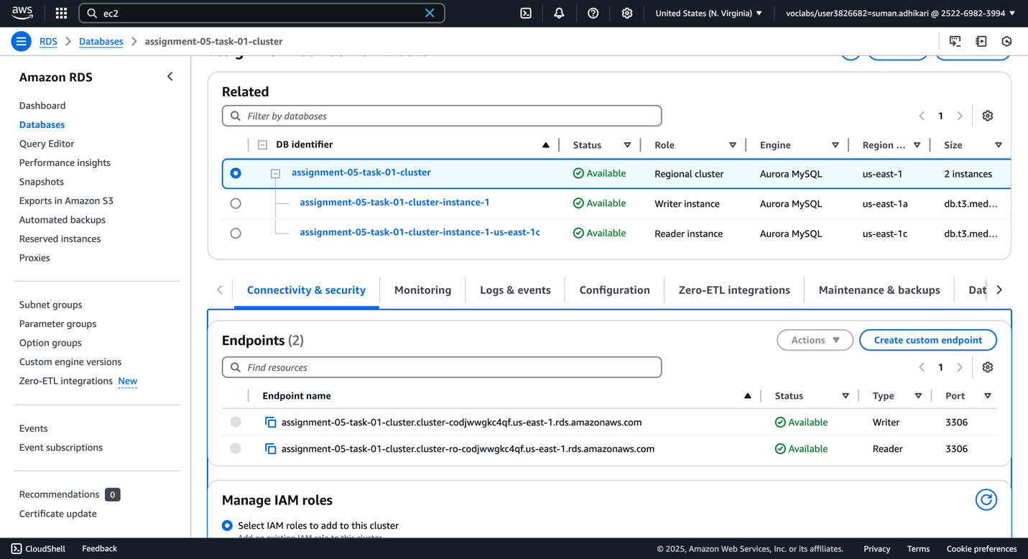

1. Create EC2 for DB access. (Bastion server)

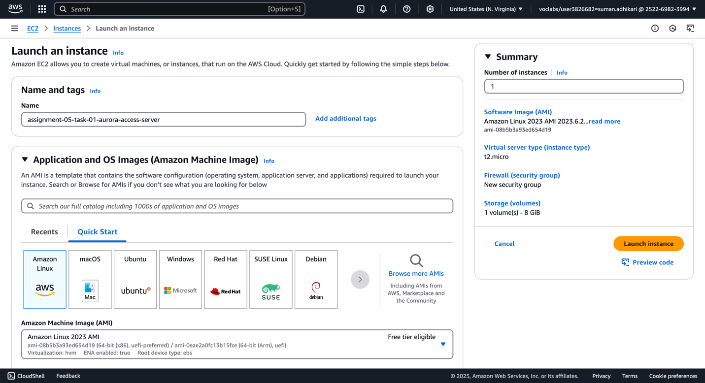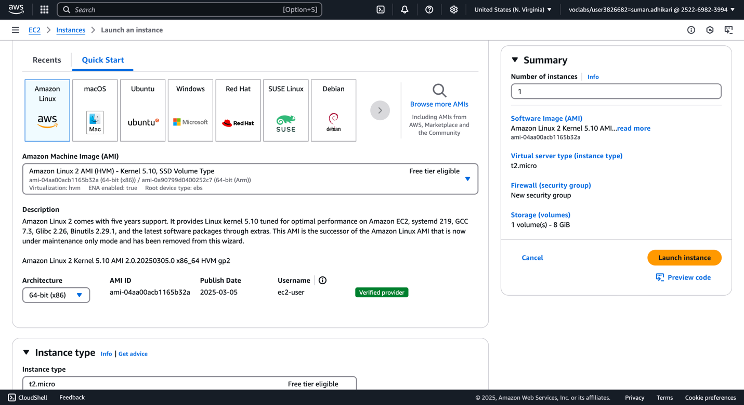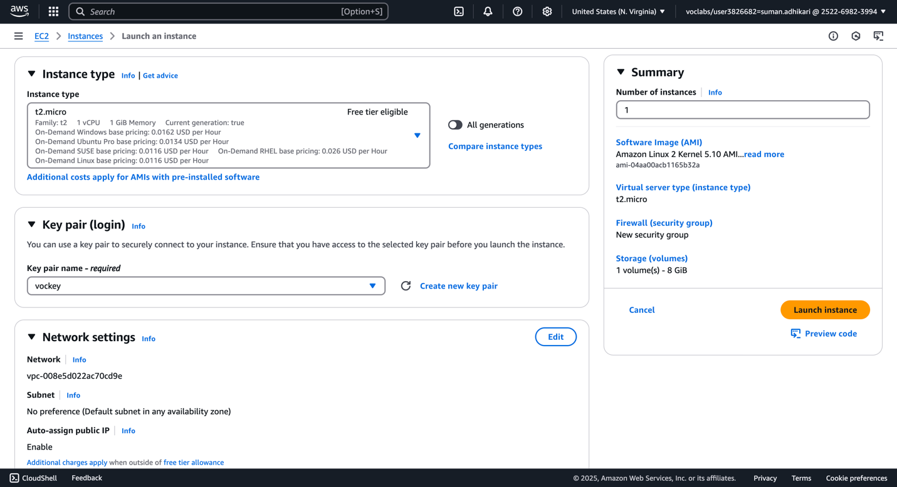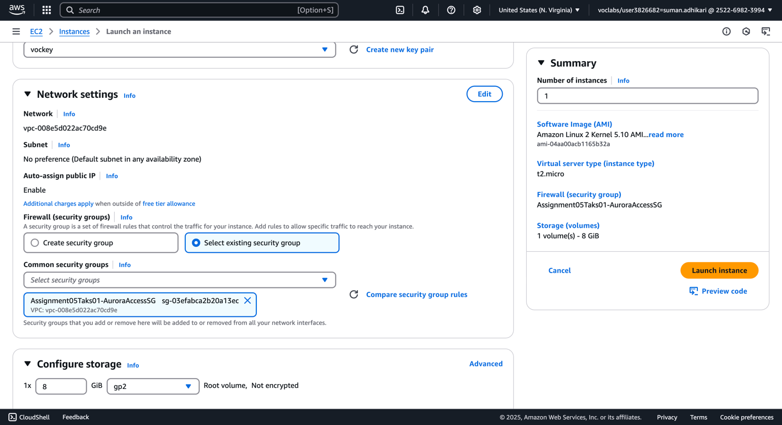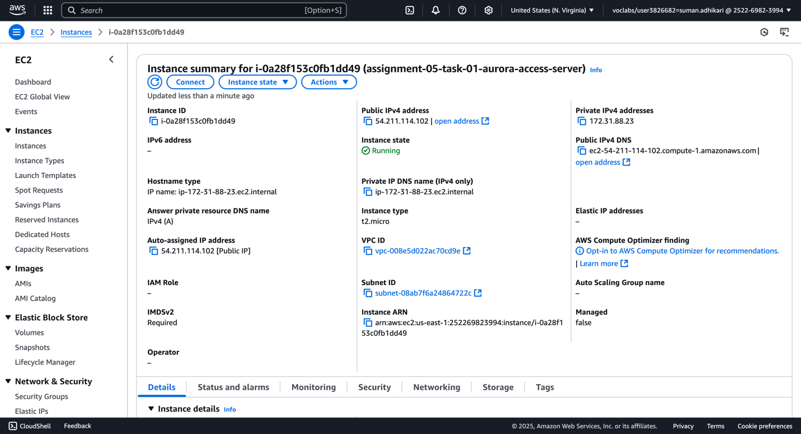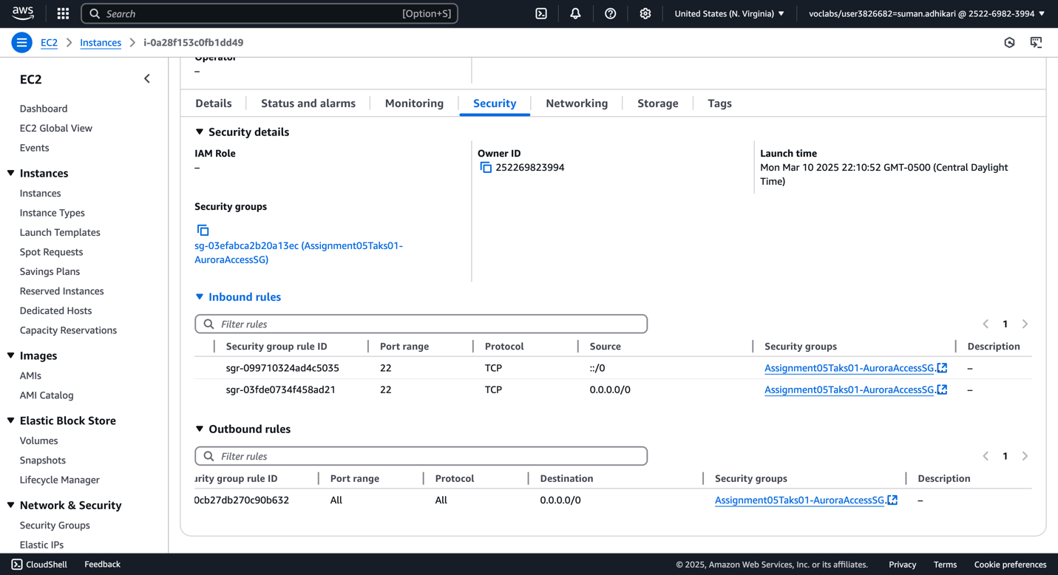

1. Install mysql client on EC2.

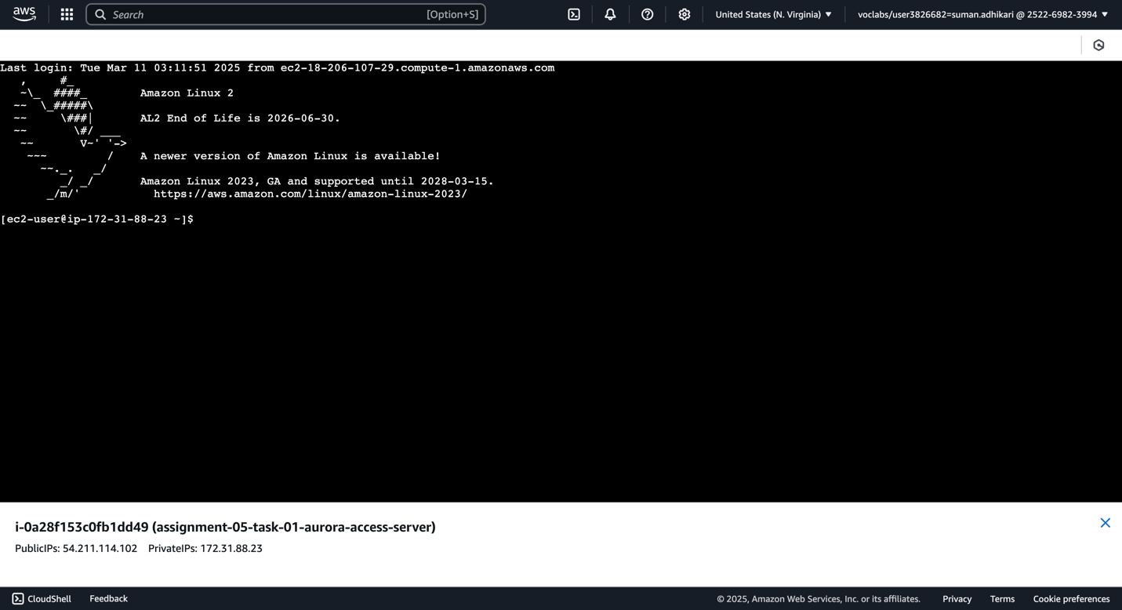

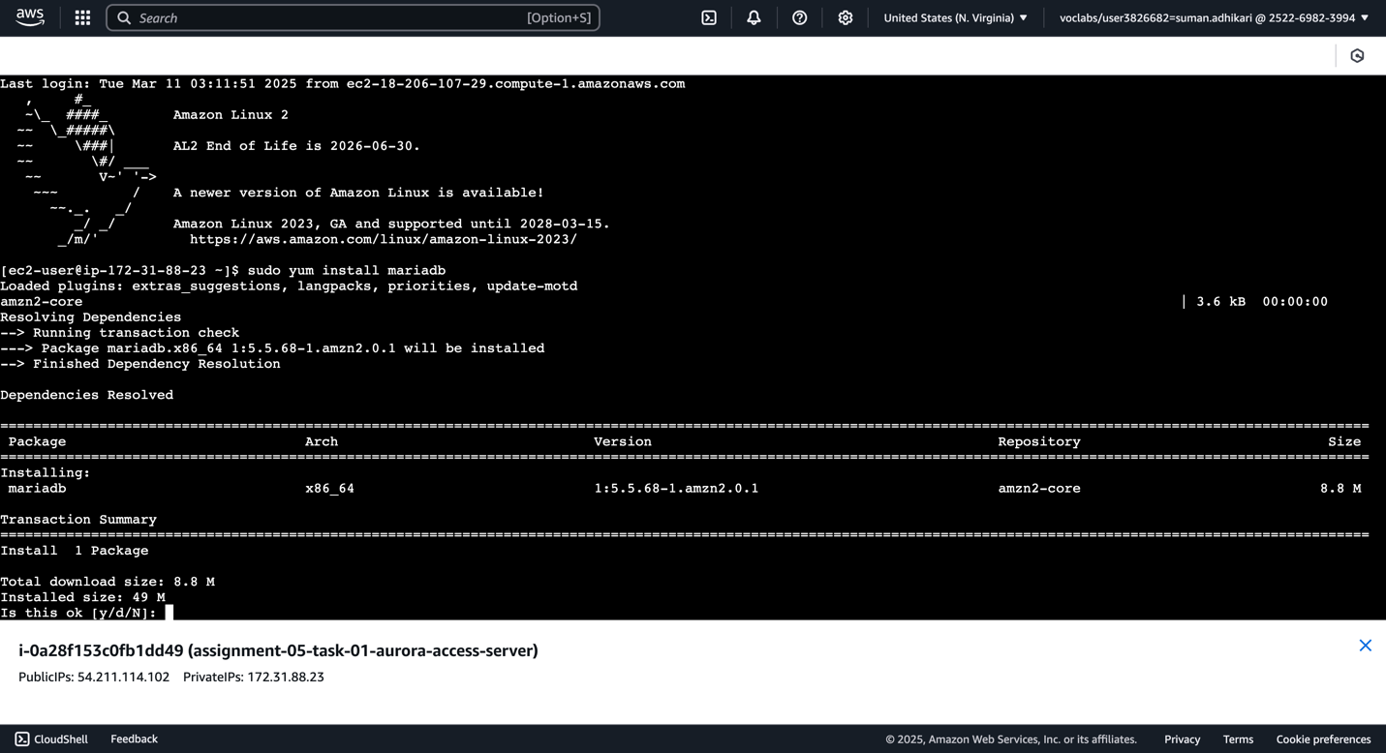

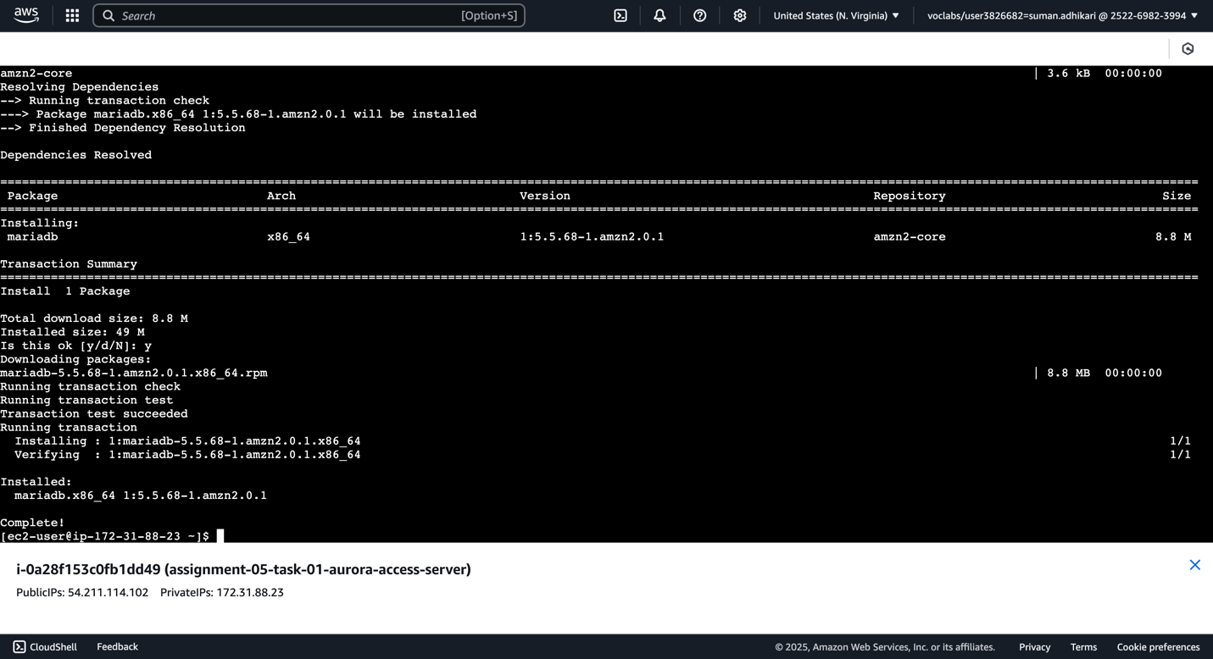

1. Connect to writer instance and create tables `products` and `orders`.

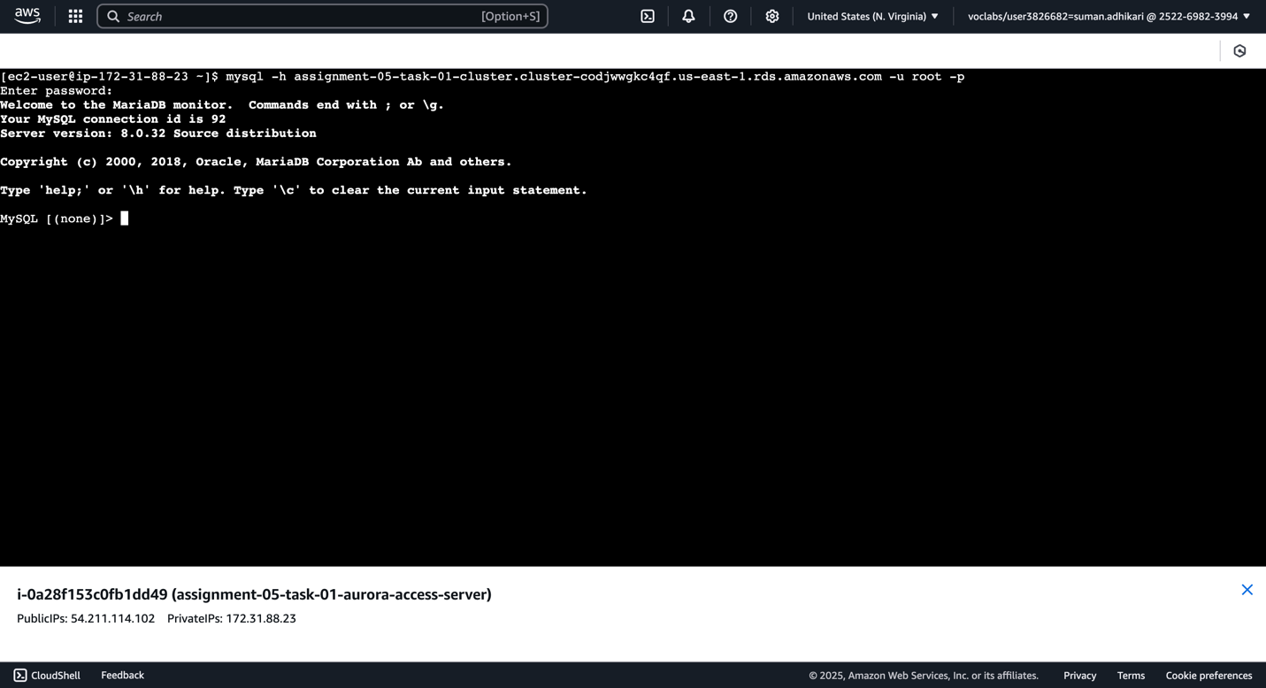

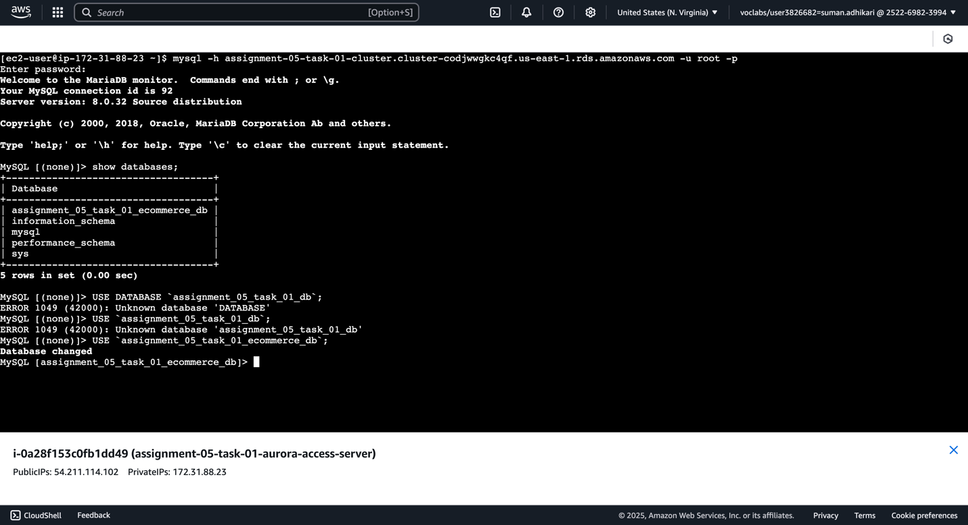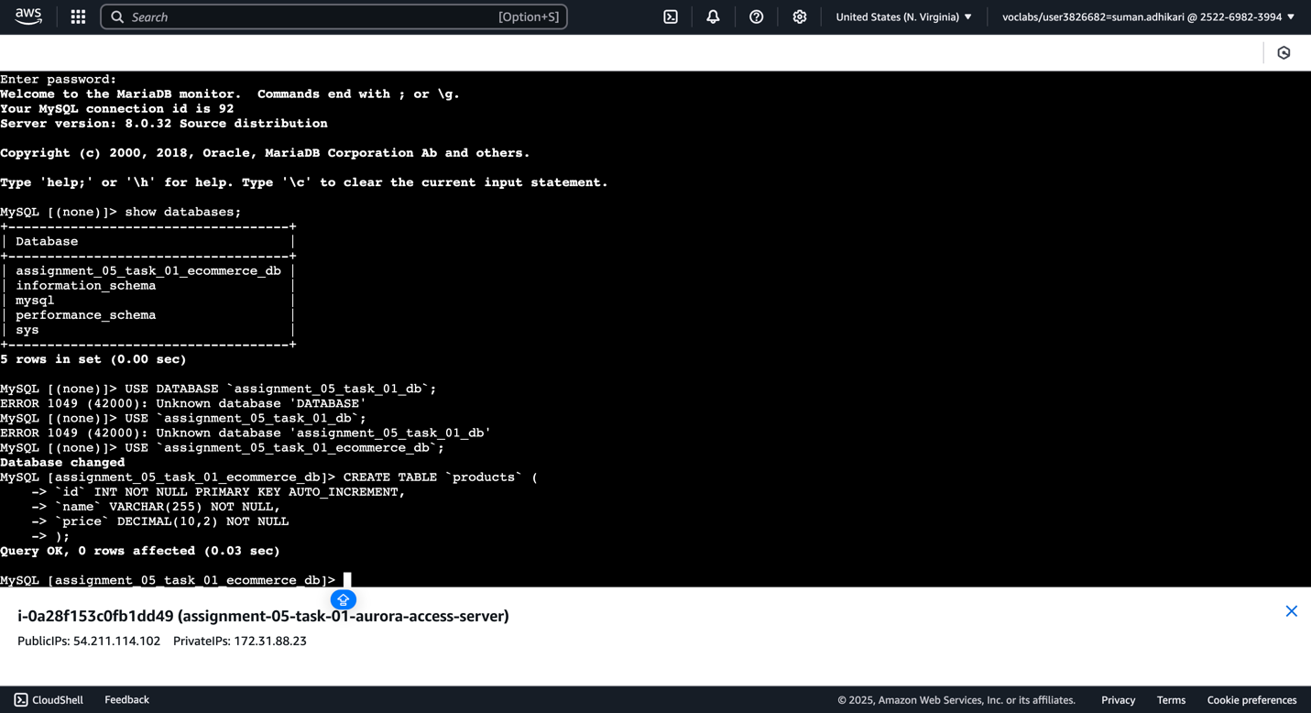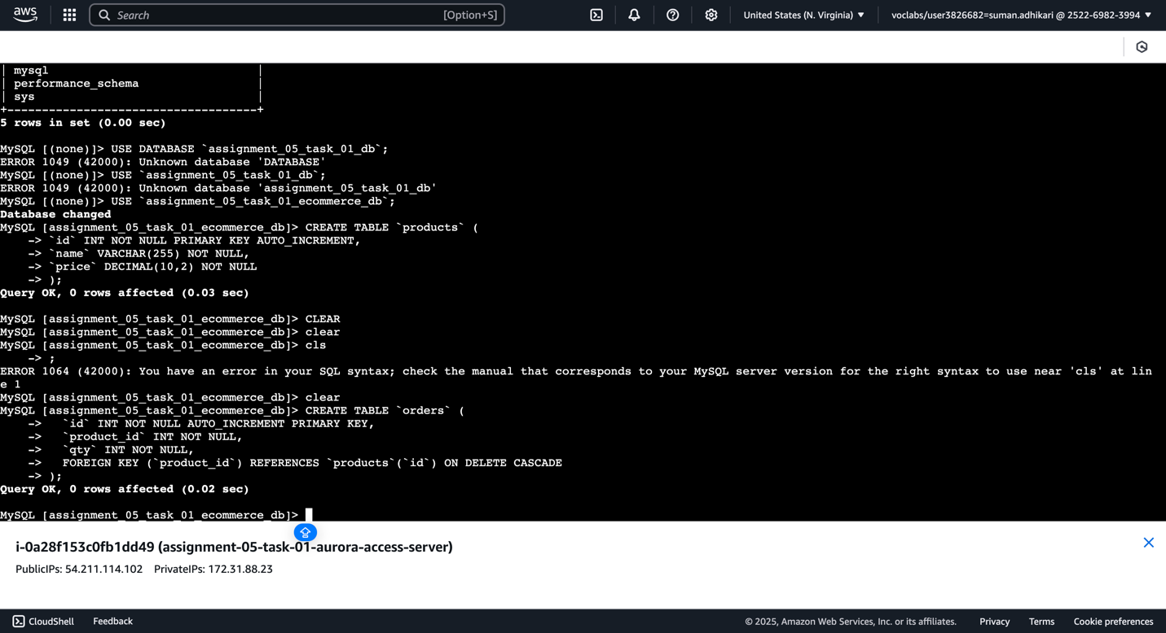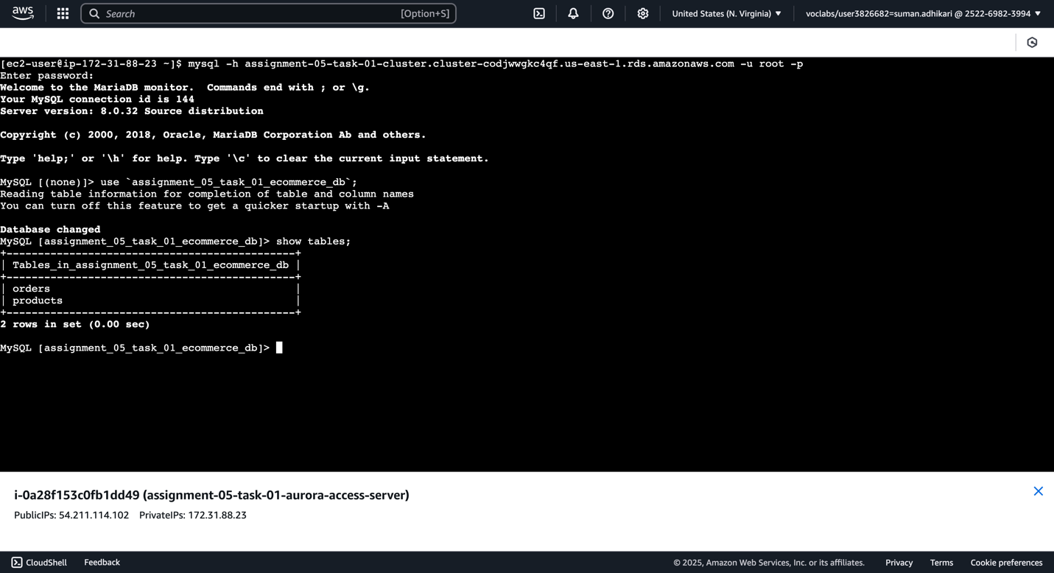

-- Use db

USE `assignment_05_task_01_ecommerce_db`;

-- create products table

CREATE TABLE `products` (

`id` INT NOT NULL PRIMARY KEY AUTO_INCREMENT,

`name` VARCHAR(255) NOT NULL,

`price` DECIMAL(10,2) NOT NULL

);

-- create orders table

CREATE TABLE `orders` (

`id` INT NOT NULL AUTO_INCREMENT PRIMARY KEY,

`product_id` INT NOT NULL,

`qty` INT NOT NULL,

FOREIGN KEY (`product_id`) REFERENCES `products`(`id`) ON DELETE CASCADE

);

1. Insert products on writer instance and verify on reader and writer instances..

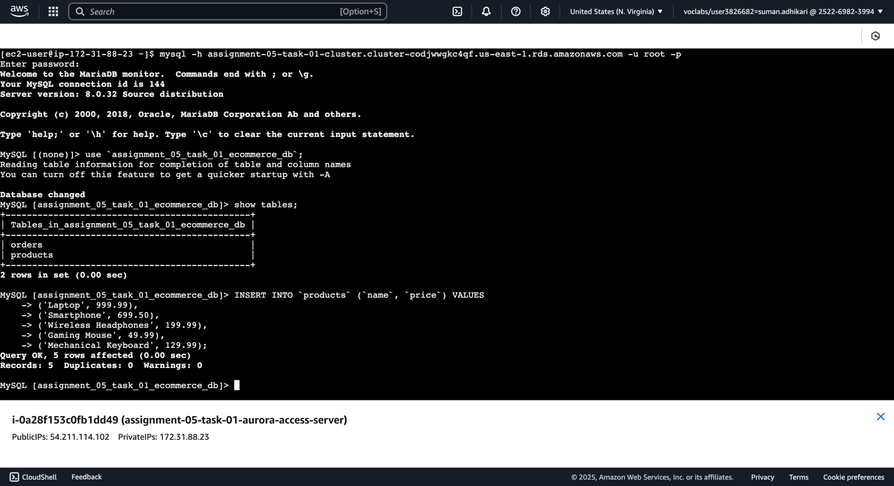

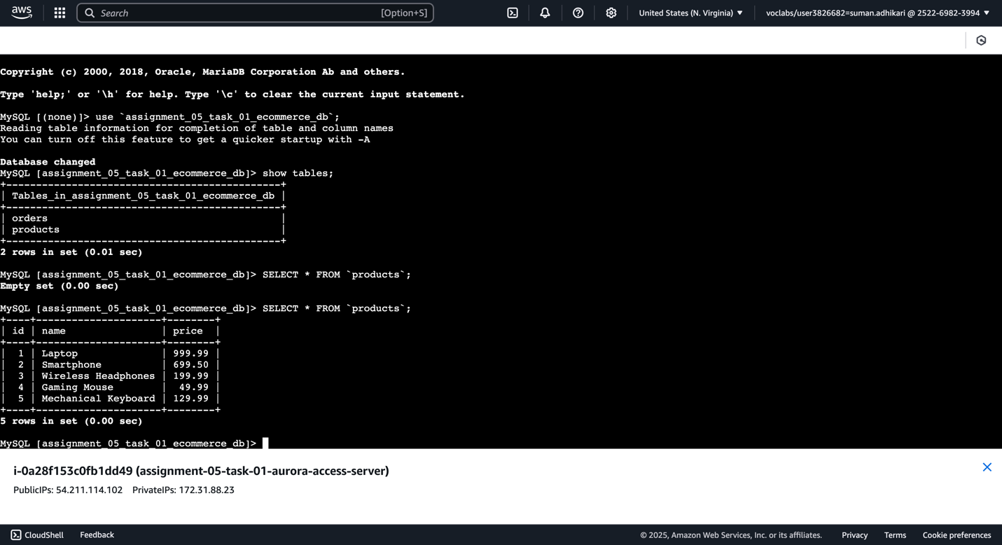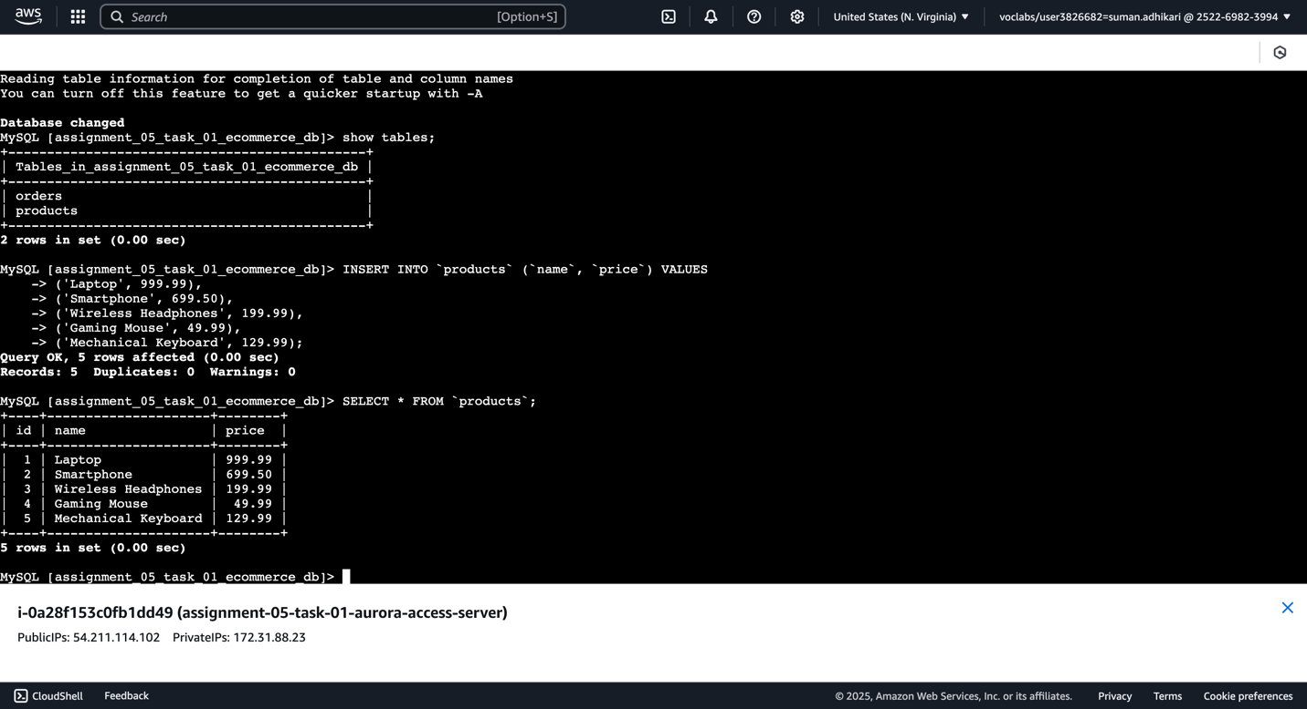

-- insert into `products` from writer instance

INSERT INTO `products` (`name`, `price`) VALUES

('Laptop', 999.99),

('Smartphone', 699.50),

('Wireless Headphones', 199.99),

('Gaming Mouse', 49.99),

('Mechanical Keyboard', 129.99);

1. Insert order from writer instances and verify on both reader and writer instances.

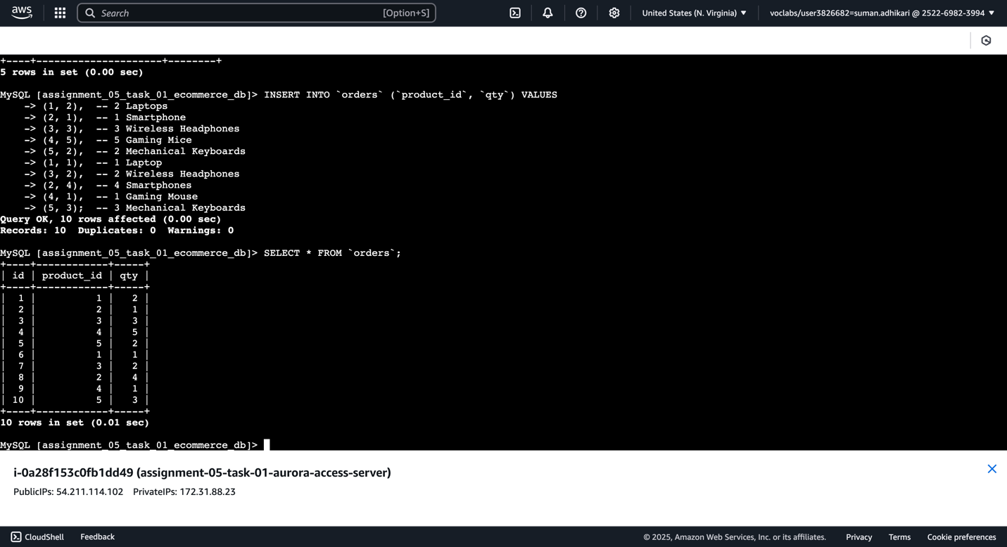

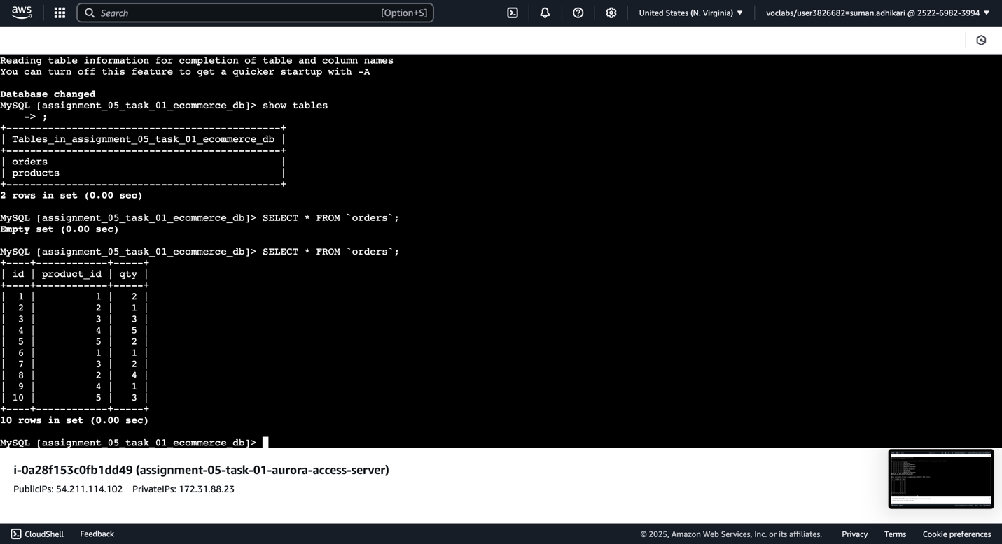



-- insert into `orders` from writer instance

INSERT INTO `orders` (`product_id`, `qty`) VALUES

(1, 2), -- 2 Laptops

(2, 1), -- 1 Smartphone

(3, 3), -- 3 Wireless Headphones

(4, 5), -- 5 Gaming Mice

(5, 2), -- 2 Mechanical Keyboards

(1, 1), -- 1 Laptop

(3, 2), -- 2 Wireless Headphones

(2, 4), -- 4 Smartphones

(4, 1), -- 1 Gaming Mouse

(5, 3); -- 3 Mechanical Keyboards

1. Try doing write operation on reader instance. It should fail by default as it is in read-only mode.

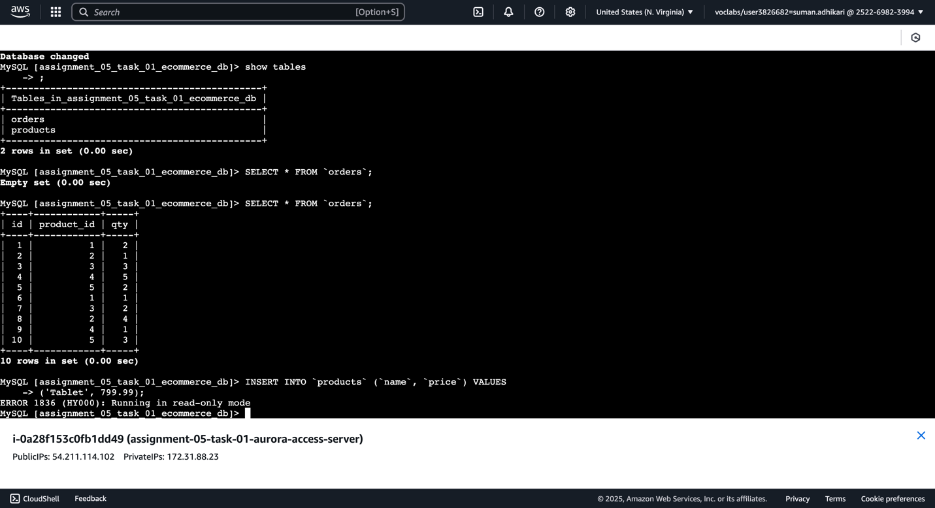

-- insert into `products` from reader instance

-- fails as instance is in reader mode

INSERT INTO `products` (`name`, `price`) VALUES ('Tablet', 799.99);

## Task #2 – Deleting Aurora DB and EC2

1. Delete all instances first. After completion delete the cluster itself and do not create any snapshots. Afterwards, delete the EC2 and any security groups involved in the assignments.

